3-Month AI Engineer Roadmap (Optimized + Practical)

🔹 MONTH 1: Strong Foundations (Most Important)

✅ Weeks 1–2: Python + Math (Don’t skip depth here)
Python (focus on real usage):
- Data structures (lists, dicts, sets)
- OOP (class, inheritance)
- Libraries:
  - NumPy (arrays, broadcasting)
  - Pandas (data cleaning, filtering)
Math (only what ML needs):
- Linear Algebra:
  - vectors, matrices, dot product
- Calculus:
  - derivatives, gradients (VERY important for backprop)
- Probability:
  - distributions (normal, binomial)
  - Bayes theorem (used in Naive Bayes)
👉 Important tip:
Don’t just read → solve small problems (e.g., implement mean, variance in Python)

✅ Weeks 3–4: Core Machine Learning
Concepts:
- Supervised vs Unsupervised
- Overfitting vs Underfitting
- Bias vs Variance
Algorithms (must know):
- Linear Regression
- Logistic Regression
- KNN
- Decision Trees
Evaluation:
- Accuracy
- Precision / Recall
- F1-score
Practice:
- Use datasets:
  - Iris
  - Titanic
👉 Use: scikit-learn

🔹 MONTH 2: Deep Learning (Real AI Starts Here)

✅ Weeks 5–6: Neural Networks
Learn deeply:
- Forward propagation
- Backpropagation (VERY important)
- Loss functions (MSE, Cross-Entropy)
- Activation functions (ReLU, Sigmoid)
Framework (choose ONE):
- PyTorch (recommended)
OR
- TensorFlow
Practice:
- Build NN from scratch (using NumPy)
- Then build same using framework

✅ Weeks 7–8: Advanced Deep Learning
Core Topics:
- CNN → image classification
- RNN / LSTM → sequences (text/time-series)
- Transfer Learning (VERY useful in real world)
Projects:
- Image classifier (cats vs dogs)
- Text classifier (spam detection)
👉 Do 2 Kaggle competitions (even beginner ones)

🔹 MONTH 3: Industry Skills (This is what gets you hired)

✅ Weeks 9–10: Modern AI (🔥 trending skills)
Must-learn topics:
- Transformers (attention mechanism)
- Fine-tuning LLMs
Use:
- Hugging Face
- LangChain
Also learn:
- Vector databases (FAISS / Pinecone)
- Prompt engineering
MLOps Basics:
- Experiment tracking:
  - MLflow
  - Weights & Biases

✅ Weeks 11–12: Portfolio + Job Prep
Build 3–4 STRONG projects:
- ML project (classification/regression)
- Deep Learning project (CNN/RNN)
- LLM-based app (Chatbot, QA system)
- Deployment project (API)
Deployment:
- Flask / FastAPI
- Streamlit
GitHub (VERY IMPORTANT):
- Clean README
- Screenshots
- Explanation of model

Lecture 1: The Basics & ML Types
This lecture introduces the "Big Three" ways computers learn and the Python tools used to build them.

1. ML Taxonomy (The Categories)
- Classification: Predicting a label (e.g., Is this email "Spam" or "Not Spam"?).
- Regression: Predicting a number (e.g., What will the price of this house be?).
- Clustering: Finding hidden groups (e.g., Grouping customers based on shopping habits).
- Sequence: Predicting the next thing in a series (e.g., Predicting the next word in a sentence).
- Decision: Taking actions to get a reward (e.g., A robot learning to walk).

2. Python Data Structures
Python uses specific "containers" to hold data:
- List: An ordered, changeable list. [1, 2, 2, 3]
- Set: Only unique items. {1, 2, 3} (The extra 2 disappears).
- Tuple: A list that cannot be changed once created. (10, 20)
- Dictionary: Key-Value pairs, like a real dictionary. {"Apple": "Red"}
- # Quick Demo
- my_list = [10, 20, 30]
- my_dict = {"name": "Gemini", "role": "AI"}
- print(my_dict["name"]) # Outputs: Gemini

Lecture 2: The ML Workflow
This is the "factory line" for building an AI. You don't just throw data at a computer; you follow a process.

1. The Workflow Steps
- Data Collection: Gathering your raw info.
- Labeling: Telling the computer what the "right answer" is for your data.
- Splitting (Train/Val/Test): You never show the computer the "test" questions while it's studying. You split data into a Training set (to learn) and a Test set (to see if it actually learned).
- Baselines: A simple starting point (like a coin flip) to see if your AI is actually doing better than random chance.

2. Code Example: Splitting Data
We use a library called scikit-learn (sklearn) to do the heavy lifting.
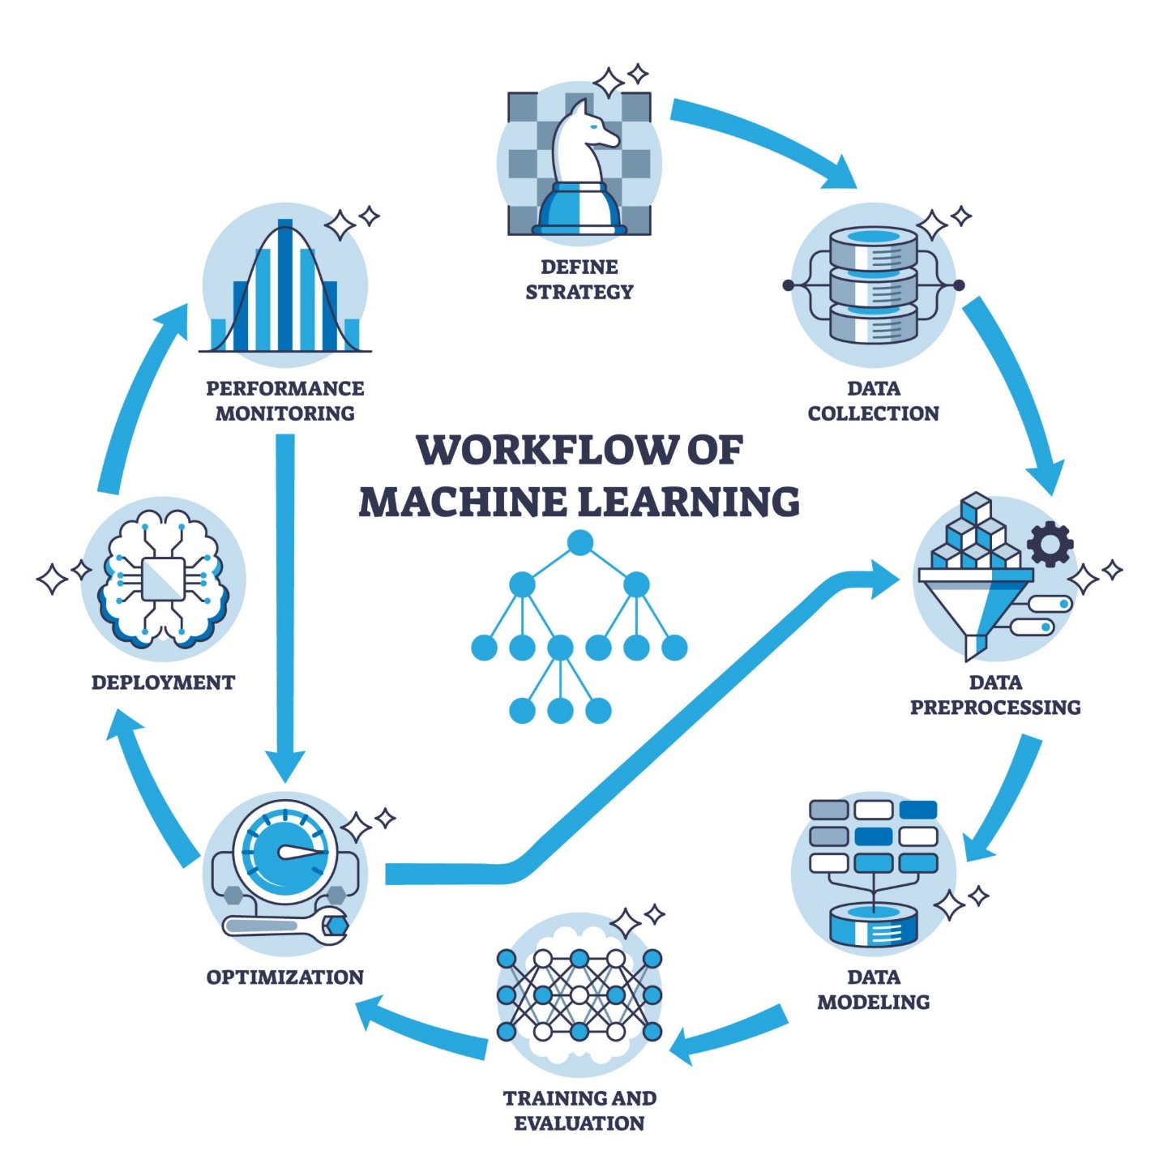from sklearn.model_selection import train_test_split
from sklearn.dummy import DummyClassifier

# X = features (data), y = labels (answers)
X_train, X_test, y_train, y_test = train_test_split(X, y, test_size=0.2)

# Create a "Dummy" model that just guesses the most common answer
model = DummyClassifier(strategy="most_frequent")
model.fit(X_train, y_train)

Lecture 3: Math & Tools
Don't let the "Math" part scare you—in ML, we mostly care about how these tools help us move and understand data.

1. Practical Math
- Vectors & Matrices: Think of a Vector as a single column in an Excel sheet and a Matrix as the entire spreadsheet. ML is basically just doing math on these spreadsheets.
- Probability & Bayes: This helps the computer say, "Given that I see a tail and whiskers, there is a 90% probability this is a cat."
- Gradients: This is how the computer "learns." If it makes a mistake, the gradient tells it which direction to move to get closer to the right answer (like the "hotter/colder" game).

2. The Power Duo: Pandas & Sklearn
- Pandas: The "Excel of Python." It's used to clean, filter, and view your data tables (called DataFrames).
- Sklearn: The "Toolbox." It contains almost every standard ML algorithm you'll need.
- import pandas as pd

- # Loading a dataset
- df = pd.read_csv("data.csv")

- # See the first 5 rows
- print(df.head())

Lecture 4: The Data Engine (NumPy & Pandas)
Before you can run a model, you have to "wrangle" the data.

1. NumPy & Pandas
- NumPy: Handles the heavy-duty math and numbers. It treats data like a giant grid of numbers.
- Pandas: This is your primary tool for data. It turns CSV files or databases into DataFrames (tables with rows and columns) that are easy to filter and change.

2. The Three Classifiers (The "Brains")
In the demo, you'll try three different ways to categorize data:
- GaussianNB (Naive Bayes): Uses simple probability. Great for text and small datasets.
- KNeighborsClassifier (KNN): Looks at the nearest "neighbors." If the 5 closest data points are "Cats," it predicts "Cat."
- SVM (Support Vector Machine): Draws a boundary line (or "fence") between different groups to keep them as far apart as possible.

Lecture 5: Visualization & EDA
EDA stands for Exploratory Data Analysis. It’s the "detective work" you do to see what your data is hiding before you build a model.

1. Visualizing Information
- Distributions (Histograms): Shows you how spread out your data is. Are most people in your dataset 20 years old or 80?
- Groupby: Splitting data into buckets (e.g., "Show me the average salary grouped by job title").
- Correlations: Finding out if two things move together. (e.g., Does "study time" increase as "test score" increases?).

2. Common Charts
- Scatterplots: Dots on a graph to see relationships between two numbers.
- Heatmaps: A color-coded grid that shows which variables are strongly related to each other.

Lecture 6: The Pro Setup & Scikit-Learn
This lecture is about making your work professional, organized, and repeatable.

1. Reproducibility
In science, if you can't repeat an experiment, it doesn't count.
- Seeds: Setting a "Random Seed" (like random_state=42) ensures that every time you run your code, the "random" shuffle happens the exact same way.
- Environments: Keeping your project's tools in a specific "box" so they don't clash with other projects.
- Saving Models: Writing your trained AI "brain" to a file so you can use it later without retraining it.

2. Deep Learning Overview
- TensorFlow & PyTorch: These are the heavy-duty frameworks used for "Deep Learning" (building Neural Networks, like the ones used for ChatGPT or self-driving cars).

3. Logistic Regression
Despite the name, this is used for Classification (predicting Yes/No). It calculates the probability of a data point belonging to a category.
from sklearn.linear_model import LogisticRegression

# 1. Create the model
model = LogisticRegression()

# 2. Fit (Train) the model
model.fit(X_train, y_train)

# 3. Predict!
predictions = model.predict(X_test)
This phase of the course is all about "data hygiene." In the real world, data is messy—it has holes, weird numbers, and text that computers can't read. These lectures teach you how to polish that data so your ML models don't get "food poisoning."

Lecture 7: Data Cleaning (The Janitor Phase)
If your data is "trash," your model’s output will be "trash." This lecture focuses on fixing mistakes.
- Missing Values: What do you do when a cell is empty?
  - Deletion: Just delete the row (risky!).
  - Imputation: Fill the hole with the average (mean) or the most common value.
- Outlier Handling: Fixing "weird" data points (like a human's age listed as 200) that would confuse the model.
- Text Cleaning: * Stemming: Cutting words down to their root (e.g., "running" becomes "run").
  - Stop Words: Removing "filler" words like the, is, at which don't add meaning.

Lecture 8: Transformations & Pipelines
Computers only speak numbers, so we have to translate everything into a format they like.
- Encoding Categorical Variables: Turning words into numbers.
  - Example: Turning "Red, Blue, Green" into "0, 1, 2".
- Scaling: Making sure all numbers are on the same scale.
  - StandardScaler: Centers data around zero.
  - MinMax: Squeezes everything between 0 and 1. (Crucial because a model might think a "Salary" of $50,000 is more important than an "Age" of 30 just because the number is bigger).
- Pipelines: A way to "glue" all your cleaning and scaling steps together so they happen automatically in order.
- from sklearn.pipeline import Pipeline
- from sklearn.preprocessing import StandardScaler
- from sklearn.linear_model import LogisticRegression

- # Creating a "factory line"
- pipeline = Pipeline([
- ('scaler', StandardScaler()),
- ('classifier', LogisticRegression())
- ])
- pipeline.fit(X_train, y_train)

Lecture 9: Feature Selection & Text Representation
More data isn't always better. Sometimes you need to pick the best features or turn complex text/images into simple numbers.
- Feature Selection: * Filter: Using math to pick the best columns.
  - Wrapper: Trying different combinations of columns to see which works best.
- Bag of Words (BoW): Counting how many times each word appears in a sentence. It ignores order but captures the "vibe."
- Word Embeddings: A smarter way to represent text where words with similar meanings (like "King" and "Queen") are placed close together in a mathematical space.
- LBP (Local Binary Patterns): A way to describe the texture of an image by looking at the pixels.
- from sklearn.feature_extraction.text import CountVectorizer

- # Bag of Words Example
- corpus = ['I love AI', 'AI is great']
- vectorizer = CountVectorizer()
- X = vectorizer.fit_transform(corpus)
- print(vectorizer.get_feature_names_out())
- # Outputs: ['ai', 'great', 'is', 'love']

Lecture 10: Probability & Bayes Rule
This is the mathematical heart of many ML models.
- Probability Review: Understanding the chance of an event happening.
- Bayes Rule: A way to update your beliefs when you get new evidence.
  - Example: If you wake up and the grass is wet, Bayes Rule helps you calculate the probability that it rained, given that the grass is wet (while considering how often it rains in your area).

Lecture 11: Naive Bayes & Independence
The "Naive" in Naive Bayes comes from one big assumption: the model assumes every feature is independent of the others. (For example, it assumes a fruit’s color and its roundness have nothing to do with each other).

The Three Variants:
- GaussianNB: Used when your data follows a "Bell Curve" (like heights or weights).
- MultinomialNB: Used for counting things (like how many times the word "Win" appears in an email).
- BernoulliNB: Used for Yes/No data (like "Does the word 'Money' appear? Yes or No").
- from sklearn.datasets import load_iris
- from sklearn.naive_base import GaussianNB

- # Iris demo
- data = load_iris()
- model = GaussianNB()
- model.fit(data.data, data.target)

Lecture 12: Text Classification & The Spam Filter
This is a classic application of ML. You’re building a system that can "read" an email and decide if it's junk.
- Tokenization: Breaking a sentence into individual words (tokens). "Hello world" $\rightarrow$ ["Hello", "world"].
- TF-IDF: A math trick to find the most important words. It gives high scores to words that appear often in one document but are rare in others (like "Mortgage" in a spam folder).
- Laplace Smoothing: A "safety net." If the model sees a word it has never seen before, it doesn't want to multiply by zero (which breaks the math). Smoothing adds a tiny bit of "fake" probability to every word so the math keeps working.
- Imbalanced Classes: What happens if 99% of your emails are "Safe" and only 1% are "Spam"? If the model just guesses "Safe" every time, it's 99% accurate but useless. You'll learn to look at Precision and Recall instead of just Accuracy.

from sklearn.feature_extraction.text import TfidfVectorizer
from sklearn.naive_bayes import MultinomialNB

# Simple Spam Pipeline
vectorizer = TfidfVectorizer()
classifier = MultinomialNB()

# Transform text to numbers, then train
X = vectorizer.fit_transform(emails)
classifier.fit(X, labels)

Lecture 13: KNN Intuition & Neighbors
KNN doesn't really "learn" a complex formula; it just memorizes the training data. When it sees a new point, it looks at the $k$ closest existing points to make a decision.
- Distance Metrics: How do we measure "closeness"?
  - Euclidean: Straight-line distance (like a bird flying).
  - Manhattan: Grid-like distance (like walking blocks in a city).
- Choosing $k$:
  - If $k$ is too small (e.g., $k=1$), the model is sensitive to noise (outliers).
  - If $k$ is too large, the boundaries get blurry and the model gets "lazy."

Lecture 14: KNN for Regression & The Curse
KNN isn't just for categories; it can predict numbers too.
- KNN Regression: Instead of taking a "vote" for a category, it takes the average of the $k$ nearest neighbors' values. (e.g., "The 3 houses near this one cost $500k, $550k, and $600k, so this one is probably $550k").
- Curse of Dimensionality: This is a famous ML problem. As you add more columns (dimensions) to your data, the points get "lonely" and move further apart. In high dimensions, every point feels far away from every other point, and "distance" loses its meaning.
- Computational Weight: KNN is "lazy." It does zero work during training but a lot of work during prediction because it has to calculate the distance to every single point in your database.

Lecture 15: Scaling & Speed
Because KNN relies entirely on distance, the scale of your numbers matters more here than in almost any other model.
- Impact of Scaling: If you have "Age" (0–100) and "Salary" (0–100,000), the distance calculation will be dominated by Salary. A difference of $1,000 looks huge to the math, while a difference of 20 years looks tiny. You must scale data for KNN.
- KD-Trees & Ball Trees: These are smart ways to organize data (like an index in a book) so the computer doesn't have to check every single point. It can quickly rule out entire groups of distant points.
- from sklearn.neighbors import KNeighborsRegressor
- from sklearn.preprocessing import StandardScaler
- from sklearn.pipeline import Pipeline

- # The "Correct" way to do KNN
- model = Pipeline([
- ('scaler', StandardScaler()),
- ('knn', KNeighborsRegressor(n_neighbors=5))
- ])

- # Training on housing data
- model.fit(X_train, y_train)
We are moving from "nearest neighbors" into Decision Trees and, finally, how to put your models on the internet!

Lecture 16: One R (One Rule) Classifier
Before learning complex trees, you study the simplest one possible.
- The Intuition: The One R classifier looks at all your features and picks the single best one that makes the fewest mistakes. It’s like a doctor saying, "If you have a fever, you're sick. If not, you're fine," and ignoring everything else.
- Hand Computations: You will likely calculate the Error Rate for each column in a small table. You count how many times a feature value (e.g., "Sky=Cloudy") correctly matches the outcome (e.g., "Rain=Yes"). The feature with the lowest error wins.

Lecture 17: Decision Trees & Overfitting
A Decision Tree is like a flow chart. If it grows too big, it becomes "too smart for its own good."
- Overfitting: This happens when the tree grows until it has a specific branch for every single row in your data. It "memorizes" the noise instead of learning the pattern. It performs 100% on training data but fails on new data.
- Complexity Control (Pruning):
  - max_depth: Limiting how many levels the tree can have (e.g., only 3 levels deep).
  - min_samples_split: Telling the tree, "Don't split this branch unless there are at least 10 people in it."
- Visualization: You'll see how a deep tree creates jagged, weird boundaries, while a shallow tree creates smooth, simple ones.
- from sklearn.tree import DecisionTreeClassifier

- # Controlling complexity
- model = DecisionTreeClassifier(max_depth=3, min_samples_leaf=5)
- model.fit(X_train, y_train)

Lecture 18: Flask & Deploying Models
Training a model in a notebook is great, but useless if no one can use it. Flask turns your Python script into a Web Server.
- The Backend: Your ML model stays "alive" in the computer's memory.
- The API: When a user enters data on a website (the "Frontend"), Flask sends that data to your model.
- The Response: The model makes a prediction (e.g., "Price = $300k") and Flask sends that number back to the user's screen.

Simple Flask Structure
from flask import Flask, request, jsonify
import joblib

app = Flask(__name__)
model = joblib.load("my_model.pkl") # Loading your saved model

@app.route('/predict', methods=['POST'])
def predict():
data = request.json['features']
prediction = model.predict([data])
return jsonify({'prediction': int(prediction[0])})

if __name__ == '__main__':
app.run(debug=True)

Lecture 19: Evaluation Metrics
Accuracy is often a lie! If you are predicting a rare disease that only 1 in 100 people have, a model that says "Nobody has it" is 99% accurate but 0% useful.
- Confusion Matrix: A $2 \times 2$ table showing exactly where the model got confused (e.g., how many "Cats" were called "Dogs").
- Precision: "Of all the times I predicted Spam, how many were actually Spam?" (Avoiding false alarms).
- Recall: "Of all the actual Spam emails out there, how many did I find?" (Avoiding missing the target).
- F1-Score: The "Middle Ground." A single number that balances both Precision and Recall.

Lecture 20: Curves and Thresholds
Most models don't just say "Yes" or "No"; they give a probability (like 0.65). You have to decide where to draw the line (the Threshold).
- ROC Curve: Plots the "True Positive Rate" against the "False Positive Rate." A perfect model hugs the top-left corner.
- PR (Precision-Recall) Curve: Used mainly when your classes are imbalanced. It shows the trade-off: if you want to find every criminal (high recall), you’ll probably annoy some innocent people (low precision).
- Thresholding: If you are a bank, you might set a high threshold for "Fraud" because you don't want to block your customers' cards by mistake.

Lecture 21: Cross-Validation & The Tradeoff
You never want to rely on just one "Train/Test" split. You might have accidentally put all the "easy" examples in your test set!
- K-Fold Cross-Validation: You split your data into $K$ pieces (folds). You train on $K-1$ pieces and test on the remaining piece. You repeat this until every piece has been the test set once.
- Stratified Splits: Ensures that if your original data has 10% "Spam," every fold also has exactly 10% "Spam."
- Bias-Variance Tradeoff:
  - High Bias (Underfitting): The model is too simple (like a straight line for a curvy pattern).
  - High Variance (Overfitting): The model is too complex and changes wildly depending on the training data.

Code Demo: Cross-Validation
from sklearn.model_selection import cross_val_score, StratifiedKFold
from sklearn.ensemble import RandomForestClassifier

model = RandomForestClassifier()
# We split the data 5 times and get 5 different accuracy scores
scores = cross_val_score(model, X, y, cv=5)

print(f"Average Accuracy: {scores.mean()}")

Lecture 22: Linear Regression & Finding the Line
Linear Regression is the "Hello World" of statistics. It tries to find the best straight line through your data points.
- OLS (Ordinary Least Squares): This is the mathematical "goal." It tries to minimize the square of the vertical distance between the actual data points and your line.
- Normal Equations: A way to solve for the best line using a single direct math formula. It's fast for small data but gets very slow if you have millions of rows.
- Gradient Descent Intuition: Imagine you are on a foggy mountain at night and want to find the bottom of the valley. You feel the slope with your feet and take a step in the steepest downward direction. You keep doing this until you reach the lowest point (the minimum error).
- Residual Plots: A "residual" is just the error (Actual Value - Predicted Value). If your line is good, these errors should look like a random cloud of dots. If they form a "U" shape, it means a straight line isn't the right tool for that data!
- from sklearn.linear_model import LinearRegression
- import matplotlib.pyplot as plt

- model = LinearRegression()
- model.fit(X_train, y_train)

- # Residual Plot
- predictions = model.predict(X_test)
- residuals = y_test - predictions
- plt.scatter(predictions, residuals)
- plt.axhline(y=0, color='r', linestyle='--') # Ideally, dots are scattered around this line

Lecture 23: The Great Comparison (Practical Examples)
This lecture is a "Battle of the Algorithms." You'll see how the models you've learned so far handle the same data.
Model | Best Used For... | Pro | Con
Naive Bayes | Text, Spam, Sentiment | Fast, works with little data | Assumes features are independent (rarely true)
KNN | Small datasets, simple patterns | Very intuitive, no "training" time | Slow to predict, hates "noisy" data
Linear Reg. | Predicting prices, trends | Easy to explain, very fast | Can only find straight-line relationships

Lecture 24: The "So What?" (Model Interpretation)
This is where you become a "Data Consultant." It’s not enough to say "My model is 85% accurate." You have to explain what that means for the business or project.
- Metric Context: If you are predicting house prices, an error of $5,000 might be "Great" for a mansion but "Terrible" for a tiny shack.
- Trade-offs: If your model has high Precision but low Recall, you are saying: "I am very sure when I say someone is sick, but I am missing a lot of sick people." Is that acceptable for your specific problem?
- Feature Importance: Looking at the "Weights" or "Coefficients." For example, if the coefficient for number_of_rooms is high, you can tell your boss: "Every extra room adds roughly $50k to the house price."

